Given formula is from binoamial expansion theorem.

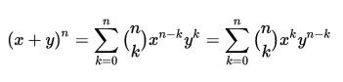

**Function Description**

Find the sum of all the coefficients for the exapnsion of equation, (A*x + B*y)^{N}.

**Input Format**

The first line of input will provide value of A.

The second line of input will provide value of B.

The third line of input will provide value of N.

**Output Format**

Display the sum of all the coefficients.

**Sample Input**

1

1

2

**Sample Output**

4

**Explanation**

**x^2 + 2*x*y + y^2**, will be the expansion of the following input, sum of 1,1,2 is 4.